Name:Ankith M Mahalathkar (1BM25CS414)

Design and implement a multi-network topology in Cisco Packet Tracer consisting of a client Local Area Network (LAN) and a server farm network separated by a Layer 3 router. Configure static IP addressing, establish network routing via Default Gateways, and host a custom HTML web page on an HTTP Server that can be dynamically resolved using a dedicated Domain Name System (DNS) Server.

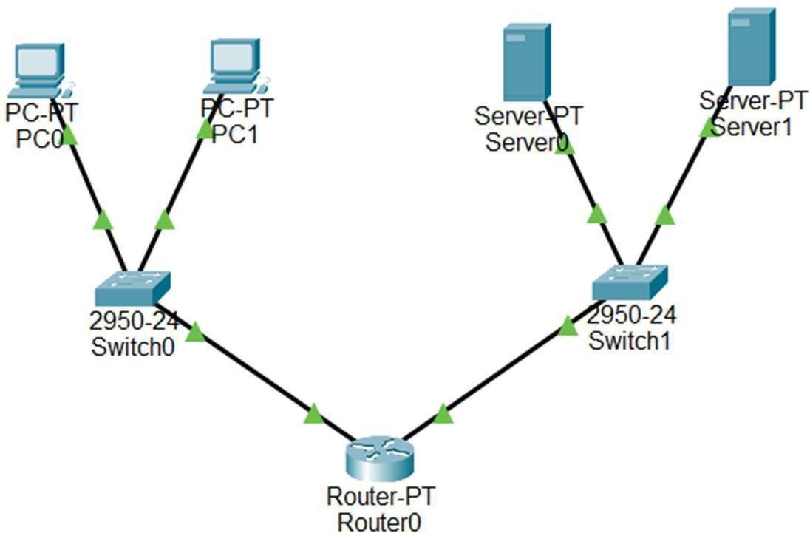

AIM
To configure and verify Domain Name System (DNS) resolution and Hypertext Transfer Protocol (HTTP) web hosting services across distinct IP subnets using Cisco Packet Tracer.
COMPONENTS / SOFTWARE REQUIRED
- Cisco Packet Tracer Software (v8.x or above)
- 1 x Router-PT (Router0)
- 2 x 2950-24 Switches (Switch0, Switch1)

- 2 x Generic Client PCs (PC0, PC1)
- 2 x Generic Servers (Server0 as DNS, Server1 as Web Server)
- Straight-Through Copper Cables

- NETWORK ADDRESSING PLAN
Device Interface IP Address Subnet Mask Default Purpose / Service

Name
Gateway

Router0 Fa0/0 192.168.1.1 255.255.255.0 N/A Gateway for Client
LAN

Router0 Fa1/0 192.168.2.1 255.255.255.0 N/A Gateway for
Server Farm

PC0 Fa0 192.168.1.10 255.255.255.0 192.168.1.1 Client End-Device

PC1 Fa0 192.168.1.11 255.255.255.0 192.168.1.1 Client End-Device

Server0 Fa0 192.168.2.10 255.255.255.0 192.168.2.1 DNS Server
(www.bmsce.edu)

Server1 Fa0 192.168.2.20 255.255.255.0 192.168.2.1 HTTP Web Server

PROCEDURE (STEP-BY-STEP)

Phase 1: Router Interface & Management Configuration
  - Click on Router0, navigate to the CLI tab, type no if prompted for the initial configuration dialog, and press Enter.
  - Type enable to enter privileged EXEC mode, then type configure terminal to enter global configuration mode.
  - Type interface FastEthernet0/0 to configure the client-side interface connection.
  - Type ip address 192.168.1.1 255.255.255.0 to assign the client-side gateway IP address.
  - Type no shutdown to change the interface status to active, then type exit.
  - Type interface FastEthernet1/0 to move into the server-side interface configuration.

  - Type ip address 192.168.2.1 255.255.255.0 to assign the server-side gateway IP address.
  - Type no shutdown to activate the server link interface.
  - Type exit to return to global configuration mode.
  - Type enable password cisco to establish the administrative privilege credential.
  - Type line vty 0 4 to initialize the five virtual lines required for remote network management access.
  - Type password bmsce to designate the login credential, then type login.
  - Type end to exit back out to the base console and type write to save the active configuration database.

Phase 2: Switch Management Configuration
  - Click on Switch0 and navigate to its CLI tab interface.
  - Type enable followed by configure terminal to open up the global customization menu.
  - Type interface vlan 1 to open the integrated logical management channel interface.
  - Type ip address 192.168.1.2 255.255.255.0 followed by no shutdown to assign the switch management IP address.
  - Type exit to leave the interface parameters configuration.
  - Type ip default-gateway 192.168.1.1 so the switch can respond across layer-3 network routes.
  - Type line vty 0 4 to set up remote configuration paths for this unit.
  - Type password bmsce to establish access parameters, type login, then type end and write to save.

Phase 3: DNS Server Setup (Server0)
  - Click on Server0, go to the Desktop tab, open IP Configuration, and input static IP parameters: 192.168.2.10, Subnet Mask: 255.255.255.0, and Default Gateway: 192.168.2.1.
  - Navigate to the Services tab at the top menu and select DNS from the left-hand column.
  - Toggle the main DNS Service state selection button to On.
  - Type www.bmsce.edu in the Name input text field.
  - Ensure the Type dropdown remains selected as A Record.
  - Type 192.168.2.20 inside the Address text input box.
  - Click the Add button to commit the resource record entry into the local system lookup cache database.

Phase 4: Web Server Setup (Server1)
  - Click on Server1, navigate to Desktop -> IP Configuration, and insert the static metrics: IP: 192.168.2.20, Subnet Mask: 255.255.255.0, and Default Gateway: 192.168.2.1.
  - Navigate over to the Services tab and select the HTTP option menu.
  - Verify that both HTTP and HTTPS server switches are shifted to the On configuration.
  - Locate the file named index.html inside the manager directory and click its corresponding Edit button.
  - Delete all baseline existing default code and replace it with this custom text markup block:
<html>
<center><font size='+2' color='blue'>Cisco Packet Tracer</font></center>
<h1>Welcome to B.M.S.C.E</h1>
<hr>Welcome to Cisco Packet Tracer. Opening doors to new opportunities. Mind Wide Open.
</html>
  - Click the Save button prompt option, confirm the system overwrite check, and exit out.

Phase 5: Client Terminal Configuration (PC0 & PC1)
  - Click on PC0, browse to Desktop -> IP Configuration, and specify static values: IP: 192.168.1.10, Subnet Mask: 255.255.255.0, and Default Gateway: 192.168.1.1.
  - Fill out the DNS Server field box with the value 192.168.2.10 to point it directly to Server0.
  - Close out the workspace and open up PC1's configuration screen.
  - Input the designated local configurations: IP: 192.168.1.11, Subnet Mask: 255.255.255.0, Default Gateway: 192.168.1.1, and DNS Server: 192.168.2.10.

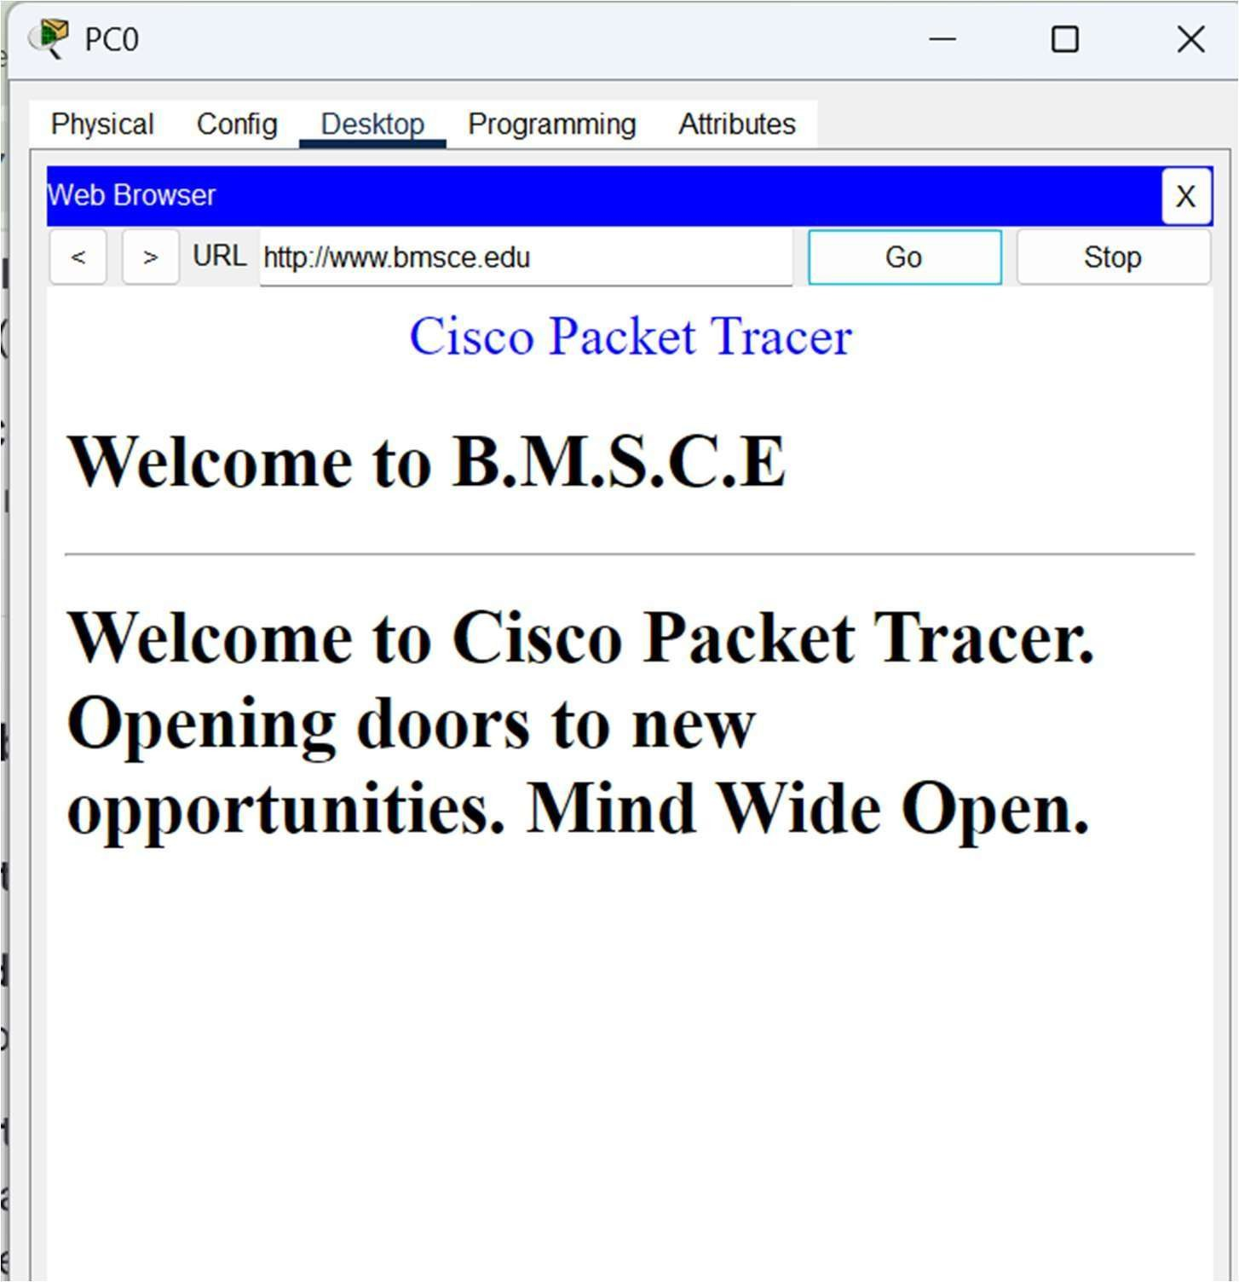

VERIFICATION & OBSERVATION
  - Open the Web Browser utility on client node PC0.
  - Type the target text domain identifier URL www.bmsce.edu into the input bar and select Go.
  - Observation: The browser successfully initiates a background translation lookup inquiry against 192.168.2.10, establishes a successful routed HTTP session crossing Router0, and explicitly pulls and presents the customized destination layout displaying: "Welcome to B.M.S.C.E".
- CONCLUSION

The deployment of a multi-network architecture with structural application layers has been successfully implemented. The application testing confirms that Layer 3 network separation handles inter-VLAN routing perfectly, and the DNS server accurately translates plain-text domains into standard machine-readable destinations to retrieve hosted web server data.

"Case Study: Subnet Mismatch Analysis":

- Observation:
When the IP address of client node PC0 was modified to 192.168.3.10 (belonging to a different network subnet) while keeping its physical connection on the Switch0-to-Router0 (Fa0/0) link, the web browser failed to resolve the domain name www.bmsce.edu and displayed a "Host Name Unresolved" error.

Why it Happened (Theoretical Reason):
  - Subnet Isolation: By changing the PC’s IP address to 192.168.3.10, it was moved into a completely different logical network (broadcast domain) than the router's interface port Fa0/0 (192.168.1.1).
  - Gateway Unreachable: A computer can only communicate with devices on its own subnet directly. Because 192.168.3.10 and 192.168.1.1 are on two entirely different subnets, PC0 can no longer communicate with its default gateway.
  - DNS Resolution Failure: Since PC0 cannot reach its gateway router, it cannot send its network packets across to the server farm subnet (192.168.2.0). It never reaches the DNS Server (192.168.2.10) to look up the website name, causing the request to drop instantly.

Conclusion of the Test:

This proves that for inter-network communication to function, a client device's logical IP subnet configuration must perfectly match the physical interface subnet of its local gateway router.

